<http://homepages.uc.edu/~boylsojh/LAB_9/index.html>

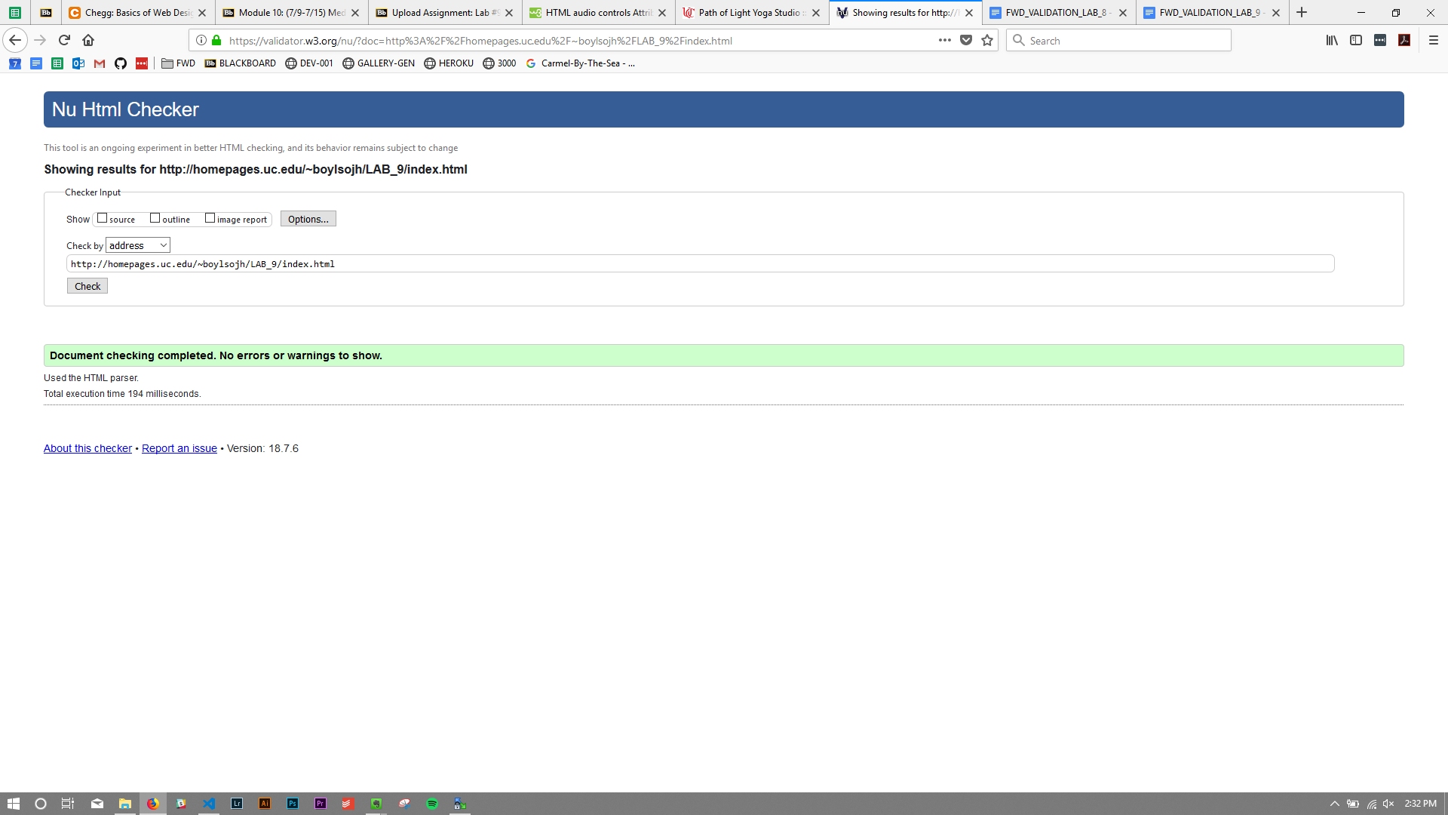

<http://homepages.uc.edu/~boylsojh/LAB_9/classes.html>

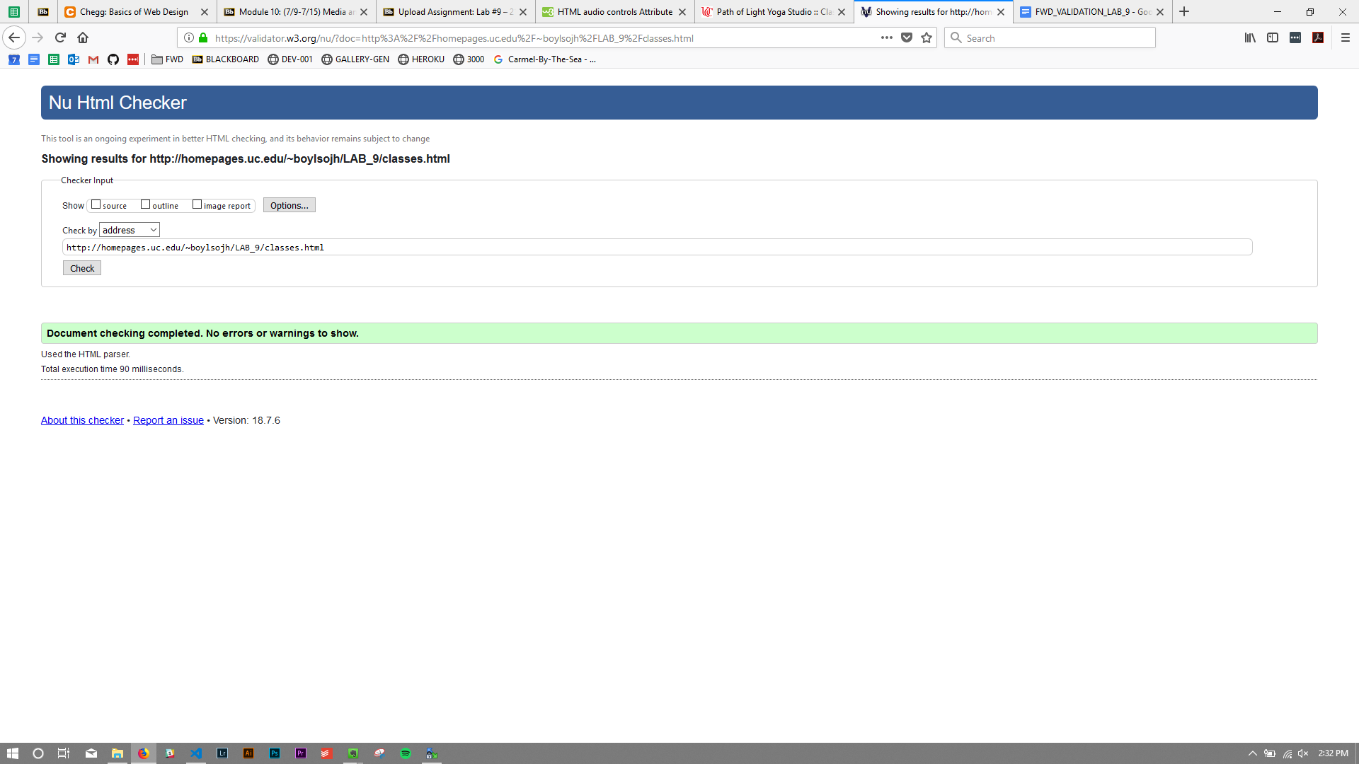

<http://homepages.uc.edu/~boylsojh/LAB_9/schedule.html>

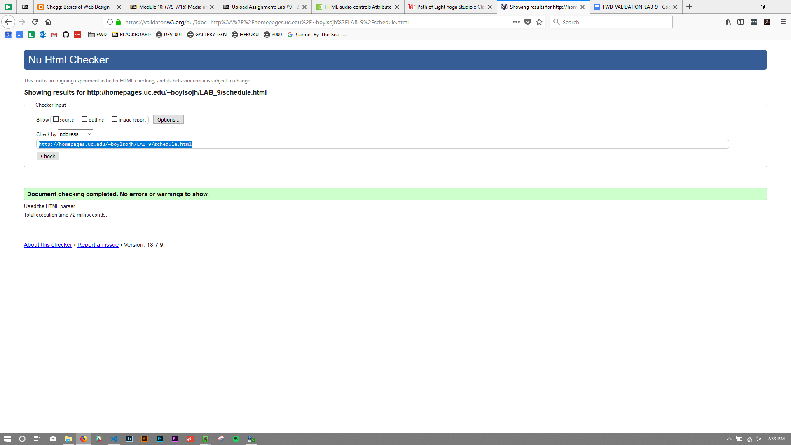

<http://homepages.uc.edu/~boylsojh/LAB_9/contact.html>

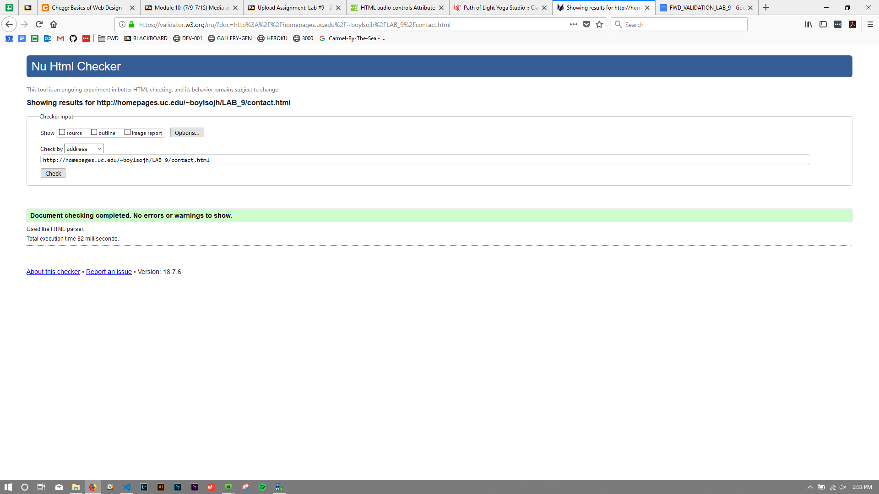

## <http://homepages.uc.edu/~boylsojh/LAB_9/yoga.css>

